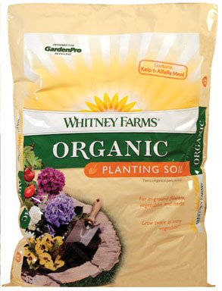
Organic Planting Soil
#6

- 1 Cubic Foot
- 100% Natural
- Ready to use

$7.99
7269426

